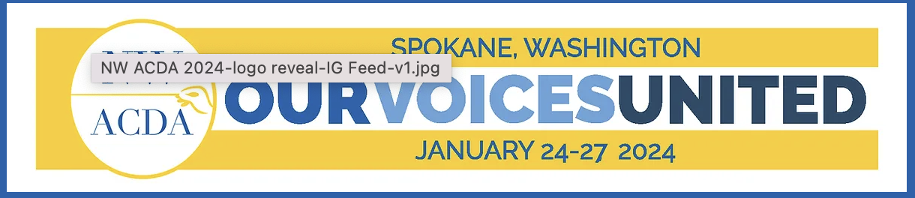

NW-ACDA 2024 Collegiate Conducting Masterclass
Faculty Endorsement

Applicant Name:

I hereby endorse the above applicant for the NW-ACDA 2024 Conducting Masterclass. I certify the applicant above is a full-time student in an undergraduate or graduate college or university music program for which I am faculty member. I also understand that if selected, this student will register for the conference.

Signature:

Title & Institution:

ACDA Member Number:

Date:

Mobile Number:

Additional Comments (optional):

